1. Install Access Database engine
   1. Double click AccessDatabaseEngine.exe to run it
   2. Click yes when prompted to provide administrator permission for the installer
   3. Follow the screens below for specific instructions on installing the Access Database engine.

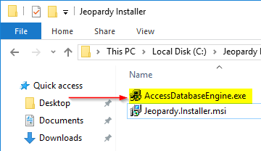

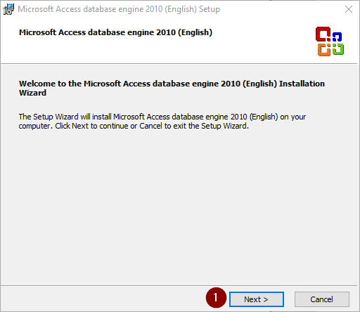

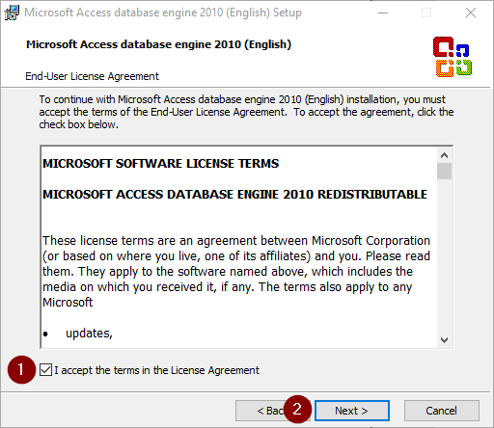

1. Install Jeopardy

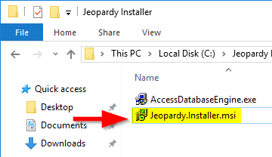

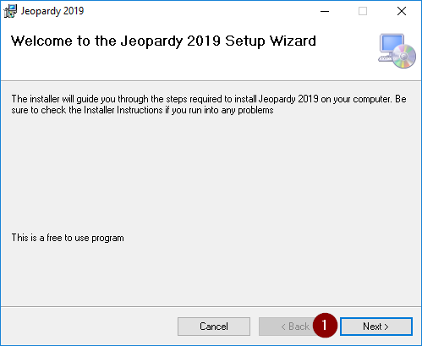

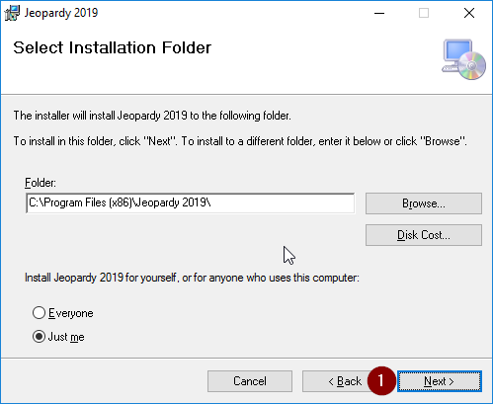

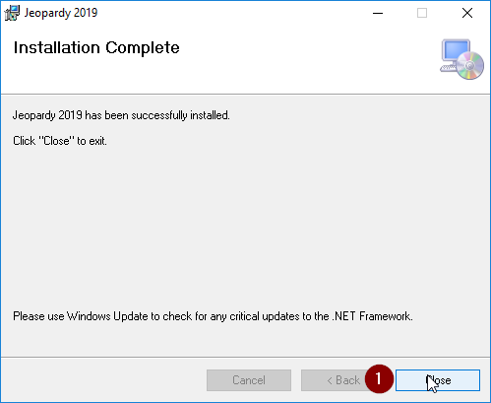

Jeopardy is now installed. There is a shortcut on the desktop. Double click the shortcut to launch the program.

